Bellshill Sharks
Open Age Group Meet
11th – 12th February 2023

Sir Matt Busby Sports Centre
Main Street, Bellshill ML4 3DP
License Number: WD/L2/009/0223
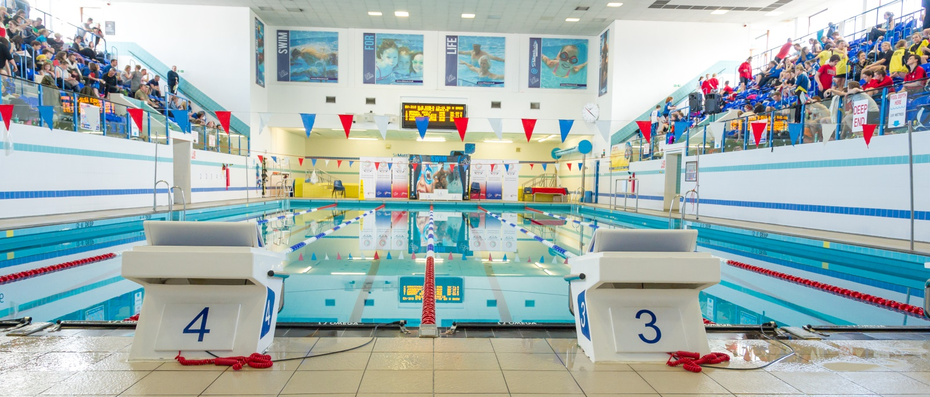

MEET INFORMATION
Date: Saturday 11th and Sunday 12th February 2020
Venue: Sir Matt Busby Sports Centre, Bellshill, Bellshill ML4 3DP
Pool: 6 x 25m with anti-turbulence lanes & full electronic timing
Timings: Warm up 08.30 and 13.00 Sat/Sun
Start 09.30 and 14.00 Sat/Sun
Ages: As on last day of meet (12/02/23)
Age groups: 9-11, 12-13, 14-15, 16 & Over
Events: 50m, 100m, 200m, 400m Free
50m, 100m & 200m Backstroke, Breaststroke & Butterfly
200m & 400m IM
)All events HDW)
Awards: All age groups – Medals 1st, 2nd & 3rd
Officials: Clubs are requested to supply at least 2 Technical Officials per
session, one of which should be qualified as a judge or above.
Entry Fees: £7.00 per individual event
Coaches Pass: £10 per coach per day (includes Programme, Results and Meal)
Closing Date: Sunday 15th January 2023
All entries should be submitted using the Hy-Tek file which can be downloaded from www.swimscotland.co.uk or requested and returned to entries@bellshillsharksasc.co.uk

Meet Rules
- The meet will be held under S.A.S.A. rules.
- Age as on the final day of the competition
- Swimmers may only enter their own age group.
- No Swimmer under the age of 9 years is permitted to swim in accordance with licence requirements
- All swimmers must have a current SASA registration number or be registered with the appropriate governing body.
- Electronic timing will be in operation. In the event of the electronic timing failing, back-up manual timing will be used
- Coaches must ensure that all swimmers can comply with the technical requirements of each stroke. This is a level 2 meet.
- Swimmers, coaches and team managers must ensure that all their swimmers can safely dive into deep or shallow water as prescribed by current/planned legislation
- No photographic or video equipment will be allowed in any area under the jurisdiction of the meet organisers without prior approval of the meet director. Application must be made on the approved S.A.S.A. form.
- It is the responsibility of each club to ensure that their swimmers are aware of the meet rules and guidelines.
Entries & Start Lists
- All entries must be made on the electronic files and submitted by email to the Meet Secretary entries@bellshillsharksasc.co.uk
- Entry files can be downloaded from www.swimscotland.co.uk or requested by email to the Meet Secretary
- All entry times must be Short Course or conversions to Short Course.
- It is the responsibility of Entry Secretaries to ensure that all entry times and dates of birth are correct
- No late entries will be accepted
- Start sheets will be prepared in advance of the meet. Any advance withdrawals should be made as early as possible to the Meet Secretary and by noon on 15th February at the latest
- On the Day Withdrawals must be made no later than 45 minutes prior to the start of each session on the withdrawal form in the coaches’ pack.
- Where an event is over-subscribed, entries may be scratched to ensure the smooth and timely running of the Meet. Scratches will be made proportionately across all age groups with slower swimmers being rejected. Rejected entries will be refunded.
- Where there are any withdrawals on the day, this will be filled by a reserve in the same age group. Where this is not possible the reserve space will be filled at the discretion of the referee.
- No Time-Only swims will be allowed or entries on the day. Bellshill Sharks reserves the right to fill any empty lanes

Events
- All events will be heat declared winner (HDW).
- Over the top starts may be used at the discretion of the promoter/referee in order to facilitate the smooth running of the meet.
- Any amendments to published Start Lists (including Reserve swims) will be released prior to the start of each session.
- Swimmers must report to the designated marshalling area at least four heats in advance. It is the responsibility of Coaches/Team Managers to ensure that their swimmers report to the marshalling area on time.
- Medals will be awarded for 1st, 2nd and 3rd in each age category – 9-11, 12-13, 14-15 and 16 and over – Age as of the final day of the meet.
- There will be no medal ceremonies, medals can be collected from the table at poolside after each event.

Consideration Times
- This meet is Open, there are NO Consideration Times
- Where an event is over-subscribed, entries may be scratched to ensure the smooth and timely running of the Meet. Scratches will be made proportionately across all age groups with slower swimmers being rejected. Rejected entries will be refunded.

Warm-up
- The warm-up will commence only when announced by the warm-up controller.
- There will be no diving allowed during the warm-up until the controlled sprint lanes are announced by the controller.
- Swimmers should keep moving during the warm-up to avoid congestion in any part of the pool.
- Sprint lanes will be introduced during the last period of each warm-up

Miscellaneous
- Accreditation has been sought via West District Licence.
- The promoters reserve the right to exclude or refuse admission to any competitor, spectator or team official.
- Swimmers and coaches must not take glassware into the shower or poolside area and are liable for expulsion from the meet if found to do so.
- Bellshill Sharks, Sir Matt Busby Sports Centre and North Lanarkshire Council (Active NL) take no responsibility for any loss or damage to swimmers, team officials or spectator’s property. Swimmers are strongly advised to secure property in the lockers provided and not leave belongings lying around unattended.
- Swimmers out-with the pool area must wear dry clothing and footwear at all times.
- Swimmers are required to have adequate footwear to travel from seating gallery to poolside.
- Anything not covered above and not printed in the meet programme will be at the promoter’s discretion.
- Bellshill Sharks reserve the right to vary the above conditions as required.
Order of Events
Session 1 – Saturday Morning | Session 2 – Saturday Afternoon
101 Girls 400 Freestyle HDW  102 Boys 200 IM HDW  103 Girls 100 Breaststroke HDW  104 Boys 100 Breaststroke HDW  105 Girls 50 Butterfly HDW  106 Boys 50 Butterfly HDW  107 Girls 200 Backstroke HDW  108 Boys 200 Backstroke HDW | 201 Girls 400 IM HDW  202 Boys 100 Freestyle HDW  203 Girls 100 Freestyle HDW  204 Boys 50 Backstroke HDW  205 Girls 50 Backstroke HDW  206 Boys 200 Breaststroke HDW  207 Girls 200 Breaststroke HDW
Session 3 – Sunday Morning | Session 4 – Sunday Afternoon
301 Boys 400 IM HDW  302 Girls 200 IM HDW  303 Boys 100 Butterfly HDW  304 Girls 100 Butterfly HDW  305 Boys 50 Breaststroke HDW  306 Girls 50 Breaststroke HDW  307 Boys 200 Freestyle HDW  308 Girls 200 Freestyle HDW | 401 Boys 400 Freestyle HDW  402 Girls 100 Backstroke HDW  403 Boys 100 Backstroke HDW  404 Girls 50 Freestyle HDW  405 Boys 50 Freestyle HDW  406 Girls 200 Butterfly HDW  407 Boys 200 Butterfly HDW

Health and Safety Announcement
Controlling the Use of Photographic Equipment

The S.A.S.A has a strict child protection policy, brought about by concerns over paedophile activity. This policy has been adopted by each member club and requires that meet organisers strictly control the use of photographic and video equipment. Therefore the use of such equipment shall be subject to the following guidelines:
No photographic equipment (e.g., camera, camcorder, camera phones etc.,) is to be allowed on either poolside, spectator gallery or any other area under the jurisdiction of the meet organisers without prior approval of the meet director.
Application to use photographic equipment must be made on the approved S.A.S.A. form which is available on request.
Application can be made on the day to the meet director or to the meet directors appointed official. Applicants must provide proof of identity when applying and carry such proof when intending to use their photographic equipment.

Health and Safety Declaration
In order to comply with accreditation and health and safety requirements, this form must be completed and returned along with entry information.
I confirm that all the entered swimmers have paid their current S.A.S.A. Annual Membership Fee (Scottish clubs) or are affiliated members of their governing body (non-Scottish clubs).
I understand that any swimmer entered without a registration number (British clubs) or not affiliated to their governing body (non-British clubs) will be automatically rejected.
I confirm that all entered swimmers have been trained and are competent to dive into deep or shallow water in a safe manner as prescribed by current/planned legislation.
I confirm that information regarding the use of photographic equipment has been passed on to swimmers and parents intending to travel to the meet.
Signed: .......................................................................................
Print Name: ………………………………………………………............
Position in club: .......................................................................................
On behalf of: .......................................................................................
(Name of club)

Return this form along with entries no later than the closing date for this competition to: entries@bellshillsharksasc.co.uk

Summary Entry Form
This form MUST be completed and returned with all entries

Club Name: .................................................................................................
Contact Name: .................................................................................................
Address: .................................................................................................
.................................................................................................
.................................................................................................
Telephone: .................................................................................................
E-Mail: .................................................................................................

Total Male Entries @ £7.00 per swim:............... £...............
Total Female entries @ £7.00 per swim:..................... £...............
Number of coaches passes @ £10.00 each Day............... £...............
Total Amount enclosed: £...............
Signed: ......................................................................................
Position in club: .......................................................................
Please make payments to the account details below using your club name as a reference
Bellshill Sharks ASC
Account No: 50049090
Sort Code: 826104
Return this form along with entries no later than the closing date for this competition to:- entries@bellshillsharksasc.co.uk

