

**Bellshill Sharks**

**Open Age Group Meet**

**14-16th November 2025**

**Sir Matt Busby Sports Centre**

**Main Street, Bellshill ML4 3DP**

**License Number: WD/L2/1125/045**

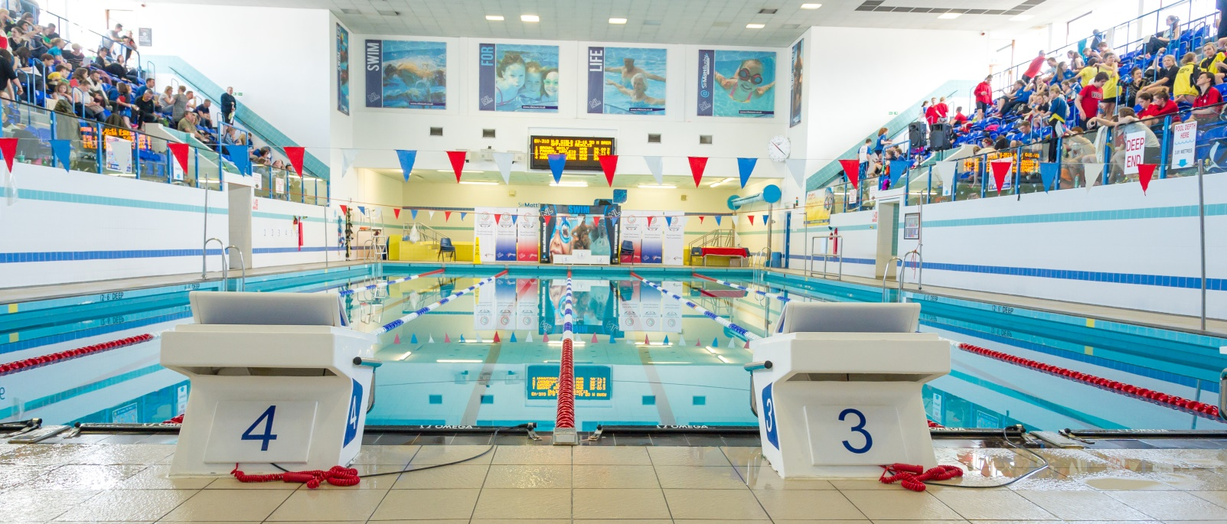

**MEET INFORMATION**

**Date: Friday 14th to Sunday 16th November 2025**

**Venue: Sir Matt Busby Sports Centre, Bellshill, Bellshill ML4 3DP**

**Pool: 6 x 25m with anti-turbulence lanes & full electronic timing**

**Timings: Warm up 6.30pm Friday**

**Start 7.00pm Friday**

**Warm up 08.30 and 13.00 Sat/Sun**

**Start 09.30 and 14.00 Sat/Sun**

**Ages: As on last day of meet (16/11/2025)**

**Awards; All events are HDW**

**Medals will be awarded in each age group for 1st, 2nd & 3rd**

**Age groups: 10-11, 12-13, 14-15, 16 & Over**

**Events: 50m, 100m, 200m, 400m, 800m, 1500m Free**

**50m, 100m & 200m Backstroke, Breaststroke & Butterfly**

**400m 200m IM**

**Distance events 800/1500m are open to those 12 years and over**

**400 IM / 400m Free are open to those 11 years and over**

**Officials: Clubs are requested to supply at least 2 Technical Officials per**

**session, one of which should be qualified as a judge or above to ensure accreditation.**

**Entry Fees: 1500m/800m £10**

**All other events £8 per swim**

**Coaches Pass: Meet Pass £25 (includes Programme, Results and Meals/Drinks etc)**

**Each team is required to purchase at least one coaches pass.**

**Closing Date: Friday 24th October 2025**

**Specific Information: For long distance events (1500m &amp; 800m) swimmers are asked to choose ONLY ONE of the two race (i.e. cannot compete in both races).**

***All entries should be submitted using the Hy-Tek file which can be downloaded from*** [**Home - Scottish Swimming - West District (scotswimwest.co.uk)**](https://www.scotswimwest.co.uk/) ***or requested and returned to*** [**entriesbellshillsharksasc@gmail.com**](mailto:entriesbellshillsharksasc@gmail.com)

***Please also complete the*** [***Summary Sheet***](https://docs.google.com/forms/d/e/1FAIpQLSeVZaXJlZUXg8lsKMomTMjae30rLP54MzpBxv8YXLyoJw_FeQ/viewform?usp=header) ***when sending your entry files.***

**Meet Rules**

* The meet will be held under world aquatics rules.
* Age as on the final day of the competition
* Swimmers may only enter their own age group.
* No Swimmer under the age of 10 years is permitted to swim in accordance with licence requirements
* All swimmers must have a current SASA registration number or be registered with the appropriate governing body.
* Electronic timing will be in operation. In the event of the electronic timing failing, back-up manual timing will be used
* Coaches must ensure that all swimmers can comply with the technical requirements of each stroke. This is a level 2 meet.
* Swimmers, coaches and team managers must ensure that all their swimmers can safely dive into deep or shallow water as prescribed by current/planned legislation
* No photographic or video equipment will be allowed in any area under the jurisdiction of the meet organisers without prior approval of the meet director. Application must be made on the approved S.A.S.A. form.
* It is the responsibility of each club to ensure that their swimmers are aware of the meet rules and guidelines.

**Entries & Start Lists**

* All entries must be made on the electronic files and submitted by email to the Meet Secretary [entriesbellshillsharksasc@gmail.com](mailto:entriesbellshillsharksasc@gmail.com)
* Entry files can be downloaded from [Home - Scottish Swimming - West District (scotswimwest.co.uk)](https://www.scotswimwest.co.uk/) or requested by email to the Meet Secretary
* All entry times must be Short Course or conversions to Short Course.
* It is the responsibility of Entry Secretaries to ensure that all entry times and dates of birth are correct
* No late entries will be accepted
* Where an event is over-subscribed, entries may be scratched to ensure the smooth and timely running of the Meet. Scratches will be made proportionately across all age groups with slower swimmers being rejected.
* Withdrawals must be notified to AOE Desk no later than 45 minutes prior to the start of each session using the withdrawal form in the coaches’ pack.
* Once start sheets have been prepared no alterations shall be made.
* Where there are any withdrawals on the day, this will be filled by a reserve in the same age group. Where this is not possible the reserve space will be filled at the discretion of the referee.
* No Time-Only swims will be allowed or entries on the day. Bellshill Sharks reserves the right to fill any empty lanes

**Payment**

* CLUBS ARE NOT REQUIRED TO SEND PAYMENT WITH ENTRIES. CLUBS WILL BE INVOICED AFTER ALL ENTRIES ARE CONFIRMED.

**Events**

* All events will be heat declared winner (HDW).
* Over the top starts may be used at the discretion of the promoter/referee in order to facilitate the smooth running of the meet.
* Any amendments to published Start Lists (including Reserve swims) will be released prior to the start of each session.
* Swimmers must report to the designated marshalling area at least four heats in advance. It is the responsibility of Coaches/Team Managers to ensure that their swimmers report to the marshalling area on time.
* Medals will be awarded for 1st, 2nd and 3rd in each age category – 10-11, 12-13, 14-15 and 16 and over – Age as of the final day of the meet.
* There will be no medal ceremonies, medals can be collected from the table at poolside after each event.

**Consideration Times**

* This meet is Open, there are NO Consideration Times

**Warm-up**

* The warm-up will commence only when announced by the warm-up controller.
* There will be no diving allowed during the warm-up until the controlled sprint lanes are announced by the controller.
* Swimmers should keep moving during the warm-up to avoid congestion in any part of the pool.
* Sprint lanes will be introduced during the last period of each warm-up

**Miscellaneous**

* Accreditation has been sought via West District Licence.
* The promoters reserve the right to exclude or refuse admission to any competitor, spectator or team official.
* Swimmers and coaches must not take glassware into the shower or poolside area and are liable for expulsion from the meet if found to do so.
* Bellshill Sharks, Sir Matt Busby Sports Centre and North Lanarkshire Council (Active NL) take no responsibility for any loss or damage to swimmers, team officials or spectator’s property. Swimmers are strongly advised to secure property in the lockers provided and not leave belongings lying around unattended.
* Swimmers out-with the pool area must wear dry clothing and footwear at all times.
* Swimmers are required to have adequate footwear to travel from seating gallery to poolside.
* Anything not covered above and not printed in the meet programme will be at the promoter’s discretion.
* Bellshill Sharks reserve the right to vary the above conditions as required.

**Order of Events**

|  |  |
| --- | --- |
| **Session 1 - Friday Evening** | |
| Mixed 800 Free HDW  Mixed 1500 Free HDW | |
| **Session 2 – Saturday Morning** | **Session 3 – Saturday Afternoon** |
| 201 Girls 400 Freestyle HDW  202 Boys 200 IM HDW  203 Girls 100 Breaststroke HDW  204 Boys 100 Breaststroke HDW  205 Girls 50 Butterfly HDW  206 Boys 50 Butterfly HDW  207 Girls 200 Backstroke HDW  208 Boys 200 Backstroke HDW | 301 Girls 400 IM HDW  302 Boys 100 Freestyle HDW  303 Girls 100 Freestyle HDW  304 Boys 50 Backstroke HDW  305 Girls 50 Backstroke HDW  306 Boys 200 Breaststroke HDW  307 Girls 200 Breaststroke HDW |
| **Session 4 – Sunday Morning** | **Session 5 – Sunday Afternoon** |
| 401 Boys 400 IM HDW  402 Girls 200 IM HDW  403 Boys 100 Butterfly HDW  404 Girls 100 Butterfly HDW  405 Boys 50 Breaststroke HDW  406 Girls 50 Breaststroke HDW  407 Boys 200 Freestyle HDW  408 Girls 200 Freestyle HDW | 501 Boys 400 Freestyle HDW  502 Girls 100 Backstroke HDW  503 Boys 100 Backstroke HDW  504 Girls 50 Freestyle HDW  505 Boys 50 Freestyle HDW  506 Girls 200 Butterfly HDW  507 Boys 200 Butterfly HDW |