

Bellshill Sharks
Open Age Group Meet
27th Feb – 1st March 2025

Sir Matt Busby Sports Centre
Main Street, Bellshill ML4 3DP
License Number: WD/L2/0226/017
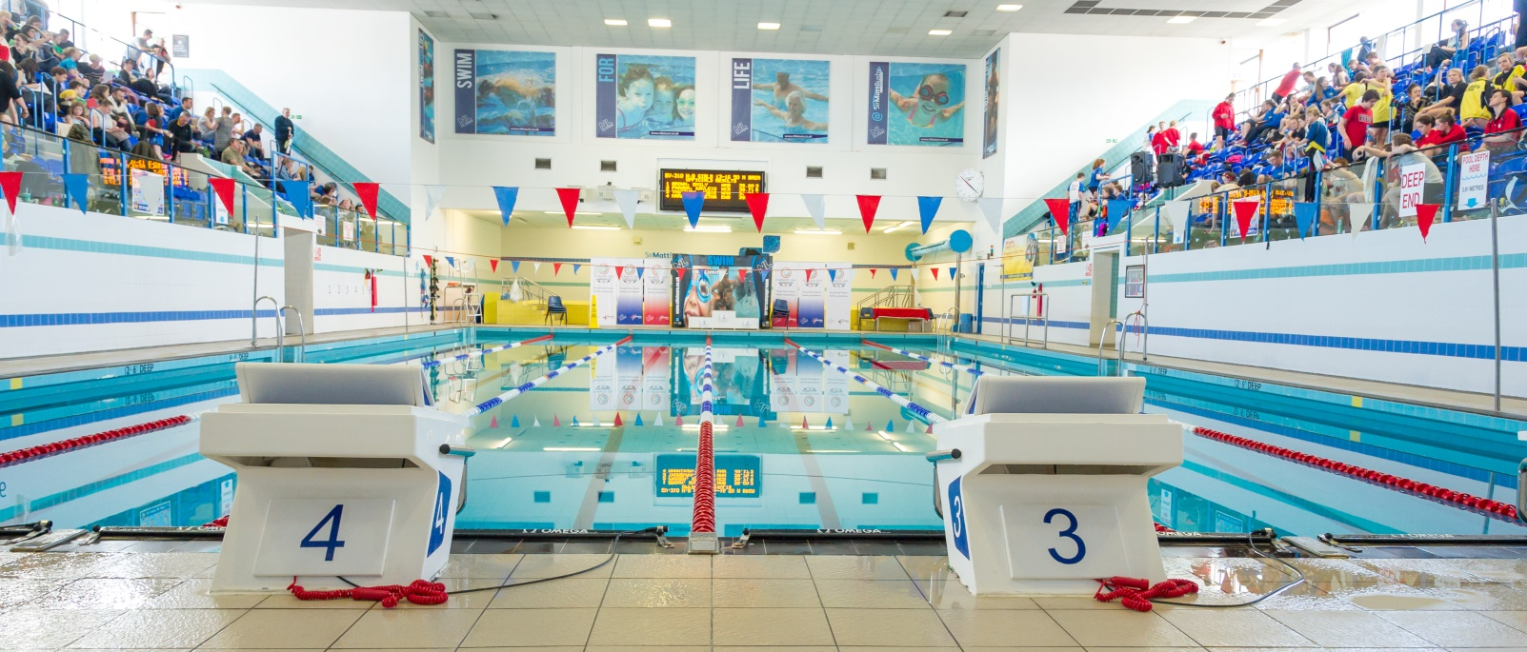

MEET INFORMATION
Date: Friday 27th February, Saturday 28th and Sunday 1st March 2026
Venue: Sir Matt Busby Sports Centre, Bellshill, Bellshill ML4 3DP
Pool: 6 x 25m with anti-turbulence lanes & full electronic timing
Timings: Warm up 18.00 Friday
Start 18.45 Friday
Warm up 08.30 and 13.00 Sat/Sun
Start 09.30 and 14.00 Sat/Sun
Ages: As on last day of meet (01/03/2026)
Age groups: 10-11, 12-13, 14-15, 16 & Over
Events: 50m, 100m, 200m, 400m, 800m, 1500m Free
50m, 100m & 200m Backstroke, Breaststroke & Butterfly
400m 200m IM

Distance events 800/1500m are open to those 12 years and over
400 IM / 400m Free are open to those 11 years and over
For long distance events (1500m & 800m) swimmers are asked to choose ONLY one of the two s (i.e. cannot compete in both races).
Awards: All age groups – Medals 1st, 2nd & 3rd
Officials: Clubs are requested to supply at least 2 Technical Officials per
session, one of which should be qualified as a judge or above.
Entry Fees: £8.00 per individual event
Coaches Pass: £25 per coach per weekend (includes Programme, Results and Meal)
Closing Date: Friday 13th February 2026
All entries should be submitted using the Hy-Tek file which can be downloaded from Home - Scottish Swimming - West District (scotswimwest.co.uk) or requested and returned to entriesbellshillsharksasc@gmail.com
Please also complete the meet summary form using this link Bellshill Sharks Open Meet 2026 Summary Sheet

Meet Rules
- The meet will be held under world aquatics rules.
- Age as on the final day of the competition
- Swimmers may only enter their own age group.
- No Swimmer under the age of 10 years is permitted to swim in accordance with licence requirements
- All swimmers must have a current SASA registration number or be registered with the appropriate governing body.
- Electronic timing will be in operation. In the event of the electronic timing failing, back-up manual timing will be used
- Coaches must ensure that all swimmers can comply with the technical requirements of each stroke. This is a level 2 meet.
- Swimmers, coaches and team managers must ensure that all their swimmers can safely dive into deep or shallow water as prescribed by current/planned legislation
- No photographic or video equipment will be allowed in any area under the jurisdiction of the meet organisers without prior approval of the meet director. Application must be made on the approved S.A.S.A. form.
- It is the responsibility of each club to ensure that their swimmers are aware of the meet rules and guidelines.
Entries & Start Lists
- All entries must be made on the electronic files and submitted by email to the Meet Secretary entriesbellshillsharksasc@gmail.com
- Entry files can be downloaded from Home - Scottish Swimming - West District (scotswimwest.co.uk) or requested by email to the Meet Secretary – entriesbellshillsharksasc@gmail.com
- All entry times must be Short Course or conversions to Short Course.
- It is the responsibility of Entry Secretaries to ensure that all entry times and dates of birth are correct
- No late entries will be accepted
- Start sheets will be prepared in advance of the meet. Any withdrawals after the program has been produced will not be refunded
- On the Day Withdrawals must be made no later than 45 minutes prior to the start of each session on the withdrawal form in the coaches’ pack.
- Where an event is over-subscribed, entries may be scratched to ensure the smooth and timely running of the Meet. Scratches will be made proportionately across all age groups with slower swimmers being rejected. Rejected entries will be refunded.
- Where there are any withdrawals on the day, this will be filled by a reserve.
- No Time-Only swims will be allowed or entries on the day. Bellshill Sharks reserves the right to fill any empty lanes

Payment
- CLUBS ARE NOT REQUIRED TO SEND PAYMENT WITH ENTRIES. CLUBS WILL BE INVOICED AFTER ALL ENTRIES ARE CONFIRMED.

Events
- All events will be heat declared winner (HDW).
- Over the top starts may be used at the discretion of the promoter/referee in order to facilitate the smooth running of the meet.
- Any amendments to published Start Lists (including Reserve swims) will be released prior to the start of each session.
- Swimmers must report to the designated marshalling area at least four heats in advance. It is the responsibility of Coaches/Team Managers to ensure that their swimmers report to the marshalling area on time.
- Medals will be awarded for 1st, 2nd and 3rd in each age category – Age as of the final day of the meet.
- There will be no medal ceremonies, medals can be collected from the table at poolside after each event.

Consideration Times
- This meet is Open, there are NO Consideration Times

Warm-up
- The warm-up will commence only when announced by the warm-up controller.
- There will be no diving allowed during the warm-up until the controlled sprint lanes are announced by the controller.
- Swimmers should keep moving during the warm-up to avoid congestion in any part of the pool.
- Sprint lanes will be introduced during the last period of each warm-up

Miscellaneous
- Accreditation has been sought via West District Licence.
- The promoters reserve the right to exclude or refuse admission to any competitor, spectator or team official.
- Swimmers and coaches must not take glassware into the shower or poolside area and are liable for expulsion from the meet if found to do so.
- Bellshill Sharks, Sir Matt Busby Sports Centre and North Lanarkshire Council (Active NL) take no responsibility for any loss or damage to swimmers, team officials or spectator’s property. Swimmers are strongly advised to secure property in the lockers provided and not leave belongings lying around unattended.
- Swimmers out-with the pool area must wear dry clothing and footwear at all times.
- Swimmers are required to have adequate footwear to travel from seating gallery to poolside.
- Anything not covered above and not printed in the meet programme will be at the promoter’s discretion.
- Bellshill Sharks reserve the right to vary the above conditions as required.
Order of Events
Session 1 – Friday Evening
101 Mixed 800m Freestyle
102 Mixed 1500m Freestyle
Session 2 – Saturday Morning | Session 3 – Saturday Afternoon
201 Girls 400m Freestyle HDW  202 Boys 200m IM HDW  203 Girls 100m Breaststroke HDW  204 Boys 100m Breaststroke HDW  205 Girls 200m Backstroke HDW  206 Boys 200m Backstroke HDW  207 Girls 50m Butterfly HDW  208 Boys 50m Butterfly HDW | 301 Boys 400m Freestyle HDW  302 Girls 100m Freestyle HDW  303 Boys 100m Freestyle HDW  304 Girls 200m Breaststroke HDW  305 Boys 200m Breaststroke HDW  306 Girls 50m Backstroke HDW  307 Boys 50m Backstroke HDW
Session 4 – Sunday Morning | Session 5 – Sunday Afternoon
401 Girls 400m IM HDW  402 Boys 100m Butterfly HDW  403 Girls 100m Butterfly HDW  404 Boys 200m Freestyle HDW  405 Girls 200m Freestyle HDW  406 Boys 50m Breaststroke HDW  407 Girls 50m Breaststroke HDW | 501 Boys 400m IM HDW  502 Girls 100m Backstroke HDW  503 Boys 100m Backstroke HDW  504 Girls 200m Butterfly HDW  505 Boys 200m Butterfly HDW  506 Girls 200m IM HDW  507 Boys 50m Freestyle HDW  508 Girls 50m Freestyle HDW

