

Bellshill Sharks
Development Meet
(A Graded Meet)
24th May 2026

Sir Matt Busby Sports Centre
Main Street, Bellshill ML4 3DP
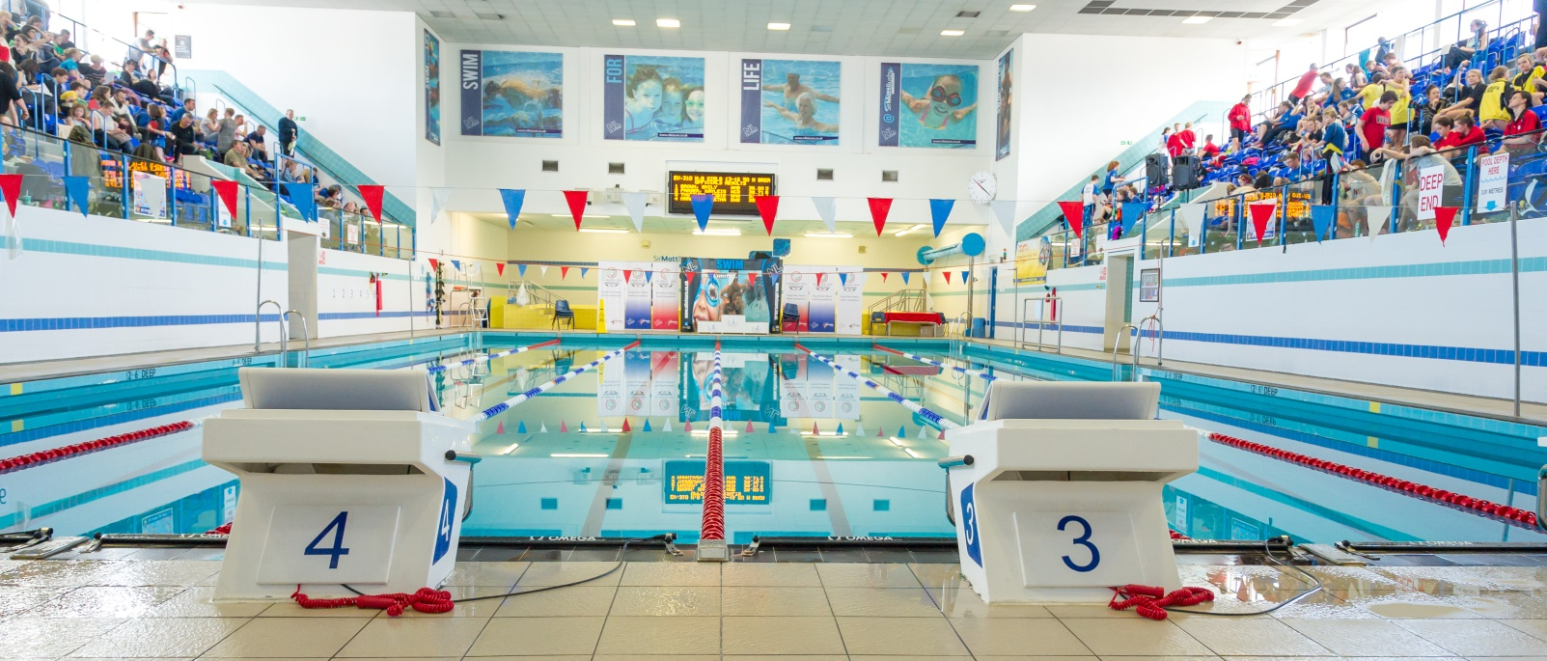
License Number: WD/L3/0526/035

MEET INFORMATION

Venue: Sir Matt Busby Sports Centre, Bellshill, Bellshill ML4 3DP
Pool: 6 x 25m with anti-turbulence lanes & full electronic timing
Timings: Warm up 08.30 and 13.00
Start 09.30 and 14.00
Ages: As of the day of the meet (24th May 2026)
Age groups: 10 and under, 11 years, 12 years, 13years,
14 and over
Events: 50m, 100m, 200m Free
50m, Backstroke, Breaststroke & Butterfly
100m IM
(ALL EVENTS HDW)
Awards: All age groups – Medals 1st, 2nd & 3rd
Officials: Clubs are requested to supply at least 2 Technical Officials per
session, one of which should be qualified as a judge or above.
Entry Fees: £8.00 per individual event
Coaches Pass: £10 per coach per day (includes Programme, Results & Meals)
Spectators: Spectating will be allowed – please note there will be an entry fee for spectators (cash only)
Closing Date: Noon on the 8th May 2025

All entries should be submitted using the Hy-Tek file which can be downloaded from West District Website or requested and returned to
entriesbellshillsharksasc@mail.com
Please also complete the meet summary form using this link Development Meet 2026 Summary Sheet

Meet Rules
- The meet will be held under SASA/World Aquatics rules. Enclosed is a health and safety form to be completed (mandatory).
- Age as on the day of the competition
- Swimmers may only enter their own age group.
- No Swimmer under the age of 8 years is permitted to swim in accordance with licence requirements
- All swimmers must have a current SASA registration number or be registered with the appropriate governing body.
- Electronic timing will be in operation. In the event of the electronic timing failing, back-up manual timing will be used
- Coaches must ensure that all swimmers can comply with the technical requirements of each stroke. This is a level 3 meet.
- Swimmers, coaches and team managers must ensure that all their swimmers can safely dive into deep or shallow water as prescribed by current/planned legislation
- No photographic or video equipment will be allowed in any area under the jurisdiction of the meet organisers without prior approval of the meet director. Application must be made on the approved S.A.S.A. form.
- It is the responsibility of each club to ensure that their swimmers are aware of the meet rules and guidelines.
Entries & Start Lists
- All entries must be made on the electronic files and submitted by email to the Meet Secretary entriesbellshillsharksasc@gmail.com
- Entry files can be downloaded from Home - Scottish Swimming - West District (scotswimwest.co.uk) or requested by email to the Meet Secretary – entriesbellshillsharksasc@gmail.com
- All entry times must be Short Course or conversions to Short Course.
- It is the responsibility of Entry Secretaries to ensure that all entry times and dates of birth are correct
- No late entries will be accepted
- Start sheets will be prepared in advance of the meet. Any withdrawals after the program has been produced will not be refunded
- On the Day Withdrawals must be made no later than 45 minutes prior to the start of each session on the withdrawal form in the coaches’ pack.
- Where an event is over-subscribed, entries may be scratched to ensure the smooth and timely running of the Meet. Scratches will be made proportionately across all age groups with slower swimmers being rejected. Rejected entries will be refunded.
- Where there are any withdrawals on the day, this will be filled by a reserve in the same age group. Where this is not possible the reserve space will be filled at the discretion of the referee.
- No Time-Only swims will be allowed or entries on the day. Bellshill Sharks reserves the right to fill any empty lanes

Payment
- CLUBS ARE NOT REQUIRED TO SEND PAYMENT WITH ENTRIES. CLUBS WILL BE INVOICED AFTER ALL ENTRIES ARE CONFIRMED.

Events
- All events will be heat declared winner (HDW).
- Over the top starts may be used at the discretion of the promoter/referee in order to facilitate the smooth running of the meet.
- Any amendments to published Start Lists (including Reserve swims) will be released prior to the start of each session.
- Swimmers must report to the designated marshalling area at least four heats in advance. It is the responsibility of Coaches/Team Managers to ensure that their swimmers report to the marshalling area on time.
- Medals will be awarded for 1st, 2nd and 3rd in each age category – Age as of the final day of the meet.
- There will be no medal ceremonies, medals can be collected from the table at poolside after each event.

Consideration Times
- Times must be slower than those detailed in the table below

Warm-up
- The warm-up will commence only when announced by the warm-up controller.
- There will be no diving allowed during the warm-up until the controlled sprint lanes are announced by the controller.
- Swimmers should keep moving during the warm-up to avoid congestion in any part of the pool.
- Sprint lanes will be introduced during the last period of each warm-up

Miscellaneous
- Accreditation has been sought via West District Licence.
- The promoters reserve the right to exclude or refuse admission to any competitor, spectator or team official.
- Swimmers and coaches must not take glassware into the shower or poolside area and are liable for expulsion from the meet if found to do so.
- Bellshill Sharks, Sir Matt Busby Sports Centre and North Lanarkshire Council (Active NL) take no responsibility for any loss or damage to swimmers, team officials or spectator’s property. Swimmers are strongly advised to secure property in the lockers provided and not leave belongings lying around unattended.
- Swimmers out-with the pool area must wear dry clothing and footwear at all times.
- Swimmers are required to have adequate footwear to travel from seating gallery to poolside.
- Anything not covered above and not printed in the meet programme will be at the promoter’s discretion.
- Bellshill Sharks reserve the right to vary the above conditions as required.

Order of Events

Saturday Morning |  |  | Saturday Afternoon
101 Mixed | 100m IM | HDW | 201 Mixed | 200m free | HDW
102 Mixed | 100m Back | HDW | 202 Mixed | 100m Breast | HDW
103 Mixed | 50m Breast | HDW | 203 Mixed | 50m Back | HDW
104 Mixed | 100m Free | HDW | 204 Mixed | 100m Fly | HDW
105 Mixed | 50 Fly | HDW | 205 Mixed | 50m Free | HDW

Consideration times (slower than)
GIRLS
Event/Age | 10 and under | 11 years | 12 years | 13 Years | 14 and Over
50m Free | 39.53 | 36.49 | 34.07 | 32.97 | 31.16
100m Free | 1.28.99 | 1.20.32 | 1:13.89 | 1:10.86 | 1:07.02
200m Free | 3.11.96 | 2.52.27 | 2.38.92 | 2:32.81 | 2:24.31
50m Back | 46.08 | 42.40 | 39.03 | 37.03 | 35.06
100m Back | 1.41.32 | 1.30.57 | 1:23.19 | 1:19.30 | 1:14.72
50m Breast | 52.93 | 47.71 | 43.73 | 41.96 | 39.67
100m Breast | 1.56.76 | 1.44.26 | 1:35.12 | 1:30.50 | 1:25.78
50m Fly | 44.74 | 40.91 | 37.68 | 35.98 | 33.87
100m Fly | 1.49.15 | 1.32.62 | 1:23.90 | 1:19.76 | 1:14.68
100m IM | 1.43.05 | 1.33.64 | 1:25.44 | 1:21.88 | 1:17.50

BOYS

Event/Age | 10 and under | 11 years | 12 years | 13 Years | 14 and Over
50m Free | 0:39.43 | 0:36.39 | 0:33.44 | 0:31.39 | 0:29.14
100m Free | 1:29.09 | 1:20.02 | 1:12.88 | 1:07.78 | 1:03.21
200m Free | 3:09.84 | 2:52.08 | 2:36.23 | 2:26.83 | 2:16.89
50m Back | 0:46.33 | 0:42.72 | 0:38.88 | 0:36.55 | 0:33.32
100m Back | 1:42.53 | 1:31.57 | 1:23.02 | 1:17.19 | 1:11.13
50m Breast | 53.30 | 0:48.53 | 0:43.49 | 0:40.66 | 0:37.17
100m Breast | 1:58.74 | 1:45.99 | 1:34.70 | 1:27.49 | 1:20.59
50m Fly | 0:45.12 | 0:41.00 | 0:37.43 | 0:34.87 | 0:31.95
100m Fly | 1:49.27 | 1:32.97 | 1:23.25 | 1:16.45 | 1:10.70
100m IM | 1:42.83 | 1:34.25 | 1:25.25 | 1:19.95 | 1:13.04

