

Spring Sprints Meeting
Saturday 25th April 2026
Spring Development Meeting
Sunday 26th April 2026

Grangemouth Sports Complex, Grangemouth

SESSIONS 1 & 3: Warm-up 09:00 Start 10:00
SESSIONS 2 & 4: Warm-up 13:30 Start 14:30

Held under licence from SASA West District
Sessions 1 & 2 on Saturday 25th Apr will be held under Licence Number: WD/L3/0426/032
Sessions 3 & 4 on Sunday 26th Apr will be held under Licence Number: WD/L3/0426/033

MEET INFORMATION

Pool | 6 lane, 25 metre pool, anti-turbulent lane ropes, full electronic timing and scoreboard, spectator area, cafeteria
Time | Session 1 & 3: warm-ups: 9.00am session starts 10.00am  Session 2 & 4: warm-ups: 1.30pm session starts 2.30pm
Events | 50m Backstroke, Breaststroke, Butterfly, Freestyle  100m Backstroke, Breaststroke, Butterfly, Freestyle  100m IM  200m IM  4 x 50m mixed freestyle relays  6 x 50m mixed freestyle relays  Swimmers can swim up an age group for relays (1 girl and 1 boy Swimmer from each age group). All events are heat declared winners. It may be necessary to limit the number of heats in certain events.
Age | Age as of 25th April 2026
Age Groups | 9 years & under, 10 years, 11 years, 12 years, 13 years, 14 years, 15 years, 16 years & over
Entry Fees | £8 per individual event  £10 per relay event
Entries | All entries must be submitted electronically to gala@forthvalleytridents.org  The Hy-Tek Team Manager Event File can be obtained from the West District and Swim Scotland websites or requested via e-mail from the same address as above.  IMPORTANT — Clubs should not submit any payments with their entries. FVT will issue invoices to clubs after the meet, based on final swims.  Any withdrawals after the confirmed and alternate swims have been circulated to the clubs will not be eligible for a refund.
Coaches Meals | £10 per meal
Awards | Medals will be awarded to 1st, 2nd,3rd, 4th,5th and 6th in each event,  which can be collected at a medal table on the day.  Relays - Medals will be awarded to 1st, 2nd and 3rd
Closing Date | Friday 27th March 2026
Meet Entry/Return Files | Entry file from and returned to: gala@forthvalleytridents.org

WhatsApp Event Channel | As well as being published on Meet Mobile, heat sheets, results, and other live event information will be published on our WhatsApp Event Channel.  Please could all coaches and team managers who will be attending the meet subscribe at their earliest convenience via the following link or QR code.  https://whatsapp.com/channel/0029VbCA8g2002T6yAaXgL3B  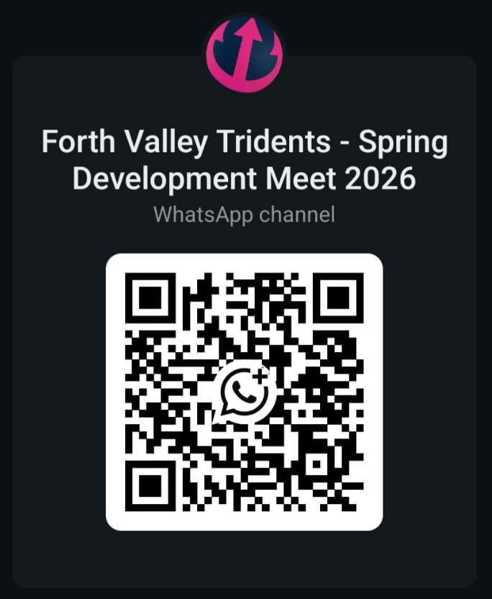

GENERAL INFORMATION
- Meet to be held under SASA rules. Enclosed is a health and safety form to be completed (mandatory).
- All swimmers of Scottish clubs must have a S.A.S.A. number.
- All swimmers of non-Scottish clubs must have registration with their governing body.
- No swimmer under the age of 7 years is permitted to swim in accordance with licence requirements.
- Start sheets will be available to clubs before the start of each session via Meet Mobile and the WhatsApp event channel. Please note that we will be minimising all printing and paper waste.
- Electronic timing will be in operation. In the event of electronic failure, back-up manual timing will be used.
- Withdrawals must be notified to the recorders no later than 40 minutes before the start of each session.
- Once start sheets have been prepared, no alterations shall be made without discussion and agreement with the Meet Management Team.
- It is the swimmer’s responsibility to check with the marshals in the allocated area. Swimmers should report to the Marshalls five heats in advance of their race. All events will be swum as heat declared winners.
- Swimmers, coaches and team managers must ensure that all their swimmers can safely dive into the deep water as prescribed by current legislation.
- There will be reserve swimmers for each event and no time only swims on the day unless with prior agreement. Would clubs also note that under no circumstances should any swimmer other than the one named on the start sheet go to the marshalling area.
- No photographic or video equipment will be allowed in any area under the jurisdiction of the meet organisers without prior approval of the meet director. An application must be made on the approved SASA form.
- Swimmers must act on the instructions given by the meet officials and always behave in a reasonable manner.
- It is the responsibility of each club to ensure that their swimmers are aware of meet rules.
- The Meet Management reserves the right to alter the programme and warm-up times if necessary. Anything not covered above or printed in the event programme will be at the gala convener’s discretion.
- The Meet Management team reserve the right to restrict entries to facilitate the smooth running of the meet. Entries will be accepted on time basis. Clubs should ensure entry times are accurate. Scratched entries will be refunded in full.
- Seeding will be determined based on entry times, and any alternates or scratches will be redistributed across the appropriate age groups. Preference for FVT swimmers when assigning day-of alternates may be exercised at the meet manager’s discretion.
- Swimmers and Coaches must not take glassware into the showers or onto poolside otherwise they will be liable for expulsion from the meet.
- FVT Committee, nor Grangemouth Sports Complex cannot be held responsible for loss or damage to swimmers, team staff or spectator’s property. Swimmers are strongly advised to secure property in the lockers provided in changing rooms and not to leave belongings lying around unattended.
- Swimmers out with the pool side must always wear dry clothing and footwear.
- Outdoor footwear must not be worn at poolside.
- Anything not covered above and not printed in the event programme will be at the promoter’s discretion.
- FVT reserves the right to vary the above conditions as necessary.
- Clubs must ensure that their coaches, team staff and swimmers are aware of the regulations and dangers of entering the water with dive starts and must be aware of pool depth and all appropriate safety procedures
- OFFICIALS Can each club supply at least 2 swimming technical official for each session of which we request 1 is a Judge. A SignupGenius form for STO’s will be provided after the closing date.
- Each club will receive an electronic welcome pack on Friday 24th April. Please note that only withdrawal forms will be provided prior to each session to limit the printing and paper waste.

SCHEDULE OF EVENTS

Spring Sprints Meet
Saturday 25th April 2026
Session 1 |  | Session 2
Warm Up 9am - Start 10am |  | Warm up 1:30pm - Start 2:30pm
101 | Mixed 10 and under 100m IM | 201 | Mixed 11/12/13 years 100m IM
102 | Mixed 9 and under 25m Butterfly | 202 | Mixed 11/12/13 years 50m Butterfly
103 | Mixed 10 years 50m Butterfly | 203 | Mixed 11/12/13 years 50m Backstroke
104 | Mixed 10 and under 50m Backstroke | 204 | Mixed 11/12/13 years 50m Breaststroke
105 | Mixed 10 and under 50m Breaststroke | 205 | Mixed 11/12/13 years 50m Freestyle
106 | Mixed 10 and under 50m Freestyle | 206 | Mixed 11/12/13 years 4x50m Freestyle relays
107 | Mixed 9 & under/10 years 4x50m Freestyle relays

Spring Development Meet

Sunday 26th April 2026
Session 3 |  | Session 4
Warm Up 9am - Start 10am |  | Warm up 1:30pm - Start 2:30pm
301 | Mixed (13 & under, 14/15/ 16 + years) 200m IM | 401 | Mixed (13 & under, 14/15/ 16 + years) 200m Freestyle
302 | Mixed (13 & under, 14/15/ 16 + years) 100m Breaststroke | 402 | Mixed (13 & under, 14/15/ 16 + years) 100m Butterfly
303 | Mixed (13 & under, 14/15/ 16 + years) 100m Freestyle | 403 | Mixed (13 & under, 14/15/ 16 + years) 100m Backstroke
 |  | 404 | Mixed (13 & under, 14/15/ 16 + years) 6x50m Freestyle relays

Over the top starts will be used where possible

CONTROLLING THE USE OF PHOTOGRAPHIC EQUIPMENT

Scottish Amateur Swimming Association has decided that control of photographic equipment is required at all meets.
In view of this, the meet will run under the following guidelines:

- No photographic equipment (e.g. Camera, Camcorder, etc) is to be allowed on poolside, spectator gallery or any other area under the jurisdiction of the meet organisers without prior approval of the meet director.

- Application to use photographic equipment must be made on the approved SASA form.

- Application can be made on the day to the meet director or to the meet directors appointed official. Applicant must provide proof of identity when applying and carry such proof when intending to use their photographic equipment.

- To comply with accreditation and health and safety requirements, this form must be completed and returned along with entry information.

HEALTH AND SAFETY ANNOUNCEMENT

I confirm that all the entered swimmers have paid their current SASA Annual Competitive Fee.

I understand that any swimmer entered without an SASA number will be automatically rejected.

I confirm that all entered swimmers have been trained and are competent to dive into deep or shallow water in a safe manner as prescribed by current/planned legislation.

I confirm that information regarding the use of photographic equipment has been passed on to swimmers and parents intending to travel to the meet.

Signed: ………………………………………………………………………

Position in Club: ………………………………………………………………………

On behalf of: …………………………………………………… (Name of Club)

Please return this form with entries no later than Friday the 27^{th of} March 2026

SUMMARY ENTRY FORM
*this form must be completed and returned with any entries*
Club Name
Club Code
Contact Name:
Address:
Telephone:
E Mail:

Total number of male entries |  | x £8 each | £
Total number of female entries |  | x £8 each | £
Total number of relay entries |  | X £10.00 each | £
Coaches pass |  | x £10.00 each | £
 |  | TOTAL = | £

Signed
Position in Club

