

Bellshill Sharks
Open Age Group Meet
14-15th November 2026

Sir Matt Busby Sports Centre
Main Street, Bellshill ML4 3DP
License Number: WD/L2/1126/053
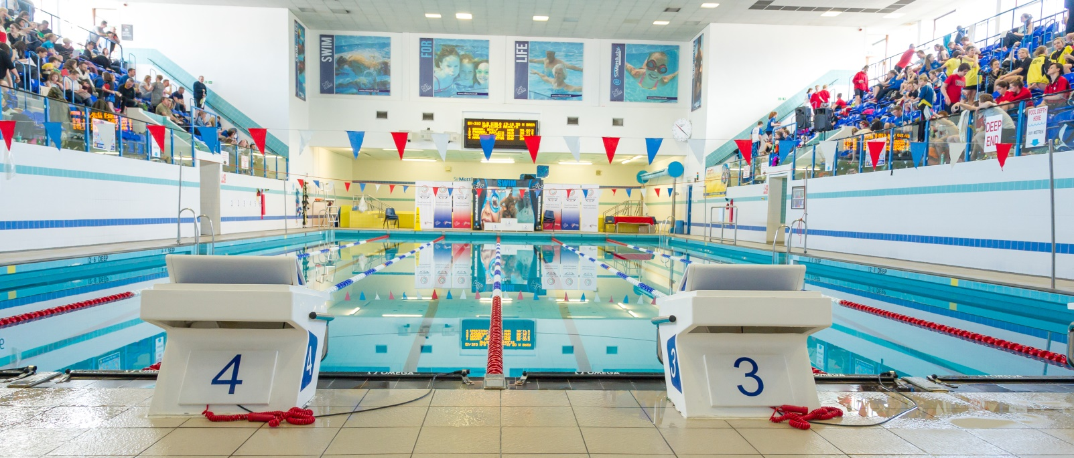

MEET INFORMATION
Date: Saturday 14th to Sunday 15th November 2026
Venue: Sir Matt Busby Sports Centre, Bellshill, Bellshill ML4 3DP
Pool: 6 x 25m with anti-turbulence lanes & full electronic timing
Timings: Warm up 08.30 and 13.00 Sat/Sun
Start 09.30 and 14.00 Sat/Sun
Ages: As on last day of meet (15/11/2026)
Awards; All events are HDW
Medals will be awarded in each age group for 1st, 2nd & 3rd
Age groups: 10-11, 12-13, 14-15, 16 & Over
Events: 50m, 100m, 200m, 400m, 800m, 1500m Free
50m, 100m & 200m Backstroke, Breaststroke & Butterfly
400m 200m IM

Distance events 800/1500m are open to those 12 years and over
400 IM / 400m Free are open to those 11 years and over

Officials: Clubs are requested to supply at least 2 Technical Officials per
session, one of which should be qualified as a judge or above to ensure accreditation.
Entry Fees: 1500m/800m £10
All other events £8 per swim
Coaches Pass: Meet Pass £20 (includes Programme, Results and Meals/Drinks etc)
Each team is required to purchase at least one coaches pass.
Closing Date: Friday 30th October 2026
All entries should be submitted using the Hy-Tek file which can be downloaded from Home - Scottish Swimming - West District (scotswimwest.co.uk) or requested and returned to entriesbellshillsharksasc@gmail.com

Please also complete the Summary Sheet when sending your entry files.

Meet Rules
- The meet will be held under world aquatics rules.
- Age as on the final day of the competition
- Swimmers may only enter their own age group.
- No Swimmer under the age of 10 years is permitted to swim in accordance with licence requirements
- All swimmers must have a current SASA registration number or be registered with the appropriate governing body.
- Electronic timing will be in operation. In the event of the electronic timing failing, back-up manual timing will be used
- Coaches must ensure that all swimmers can comply with the technical requirements of each stroke. This is a level 2 meet.
- Swimmers, coaches and team managers must ensure that all their swimmers can safely dive into deep or shallow water as prescribed by current/planned legislation
- No photographic or video equipment will be allowed in any area under the jurisdiction of the meet organisers without prior approval of the meet director. Application must be made on the approved S.A.S.A. form.
- It is the responsibility of each club to ensure that their swimmers are aware of the meet rules and guidelines.
Entries & Start Lists
- All entries must be made on the electronic files and submitted by email to the Meet Secretary entriesbellshillsharksasc@gmail.com
- Entry files can be downloaded from Home - Scottish Swimming - West District (scotswimwest.co.uk) or requested by email to the Meet Secretary
- All entry times must be Short Course or conversions to Short Course.
- It is the responsibility of Entry Secretaries to ensure that all entry times and dates of birth are correct
- No late entries will be accepted
- Where an event is over-subscribed, entries may be scratched to ensure the smooth and timely running of the Meet. Scratches will be made proportionately across all age groups with slower swimmers being rejected.
- Withdrawals must be notified to AOE Desk no later than 45 minutes prior to the start of each session using the withdrawal form in the coaches’ pack.
- Once start sheets have been prepared no alterations shall be made.
- Where there are any withdrawals on the day, this will be filled by a reserve in the same age group. Where this is not possible the reserve space will be filled at the discretion of the referee.
- No Time-Only swims will be allowed or entries on the day. Bellshill Sharks reserves the right to fill any empty lanes
Payment
- CLUBS ARE NOT REQUIRED TO SEND PAYMENT WITH ENTRIES. CLUBS WILL BE INVOICED AFTER ALL ENTRIES ARE CONFIRMED.

Events
- All events will be heat declared winner (HDW).
- Over the top starts may be used at the discretion of the promoter/referee in order to facilitate the smooth running of the meet.
- Any amendments to published Start Lists (including Reserve swims) will be released prior to the start of each session.
- Swimmers must report to the designated marshalling area at least four heats in advance. It is the responsibility of Coaches/Team Managers to ensure that their swimmers report to the marshalling area on time.
- Medals will be awarded for 1st, 2nd and 3rd in each age category – 10-11, 12-13, 14-15 and 16 and over – Age as of the final day of the meet.
- There will be no medal ceremonies, medals can be collected from the table at poolside after each event.

Consideration Times
- This meet is Open, there are NO Consideration Times

Warm-up
- The warm-up will commence only when announced by the warm-up controller.
- There will be no diving allowed during the warm-up until the controlled sprint lanes are announced by the controller.
- Swimmers should keep moving during the warm-up to avoid congestion in any part of the pool.
- Sprint lanes will be introduced during the last period of each warm-up

Miscellaneous
- Accreditation has been sought via West District Licence.
- The promoters reserve the right to exclude or refuse admission to any competitor, spectator or team official.
- Swimmers and coaches must not take glassware into the shower or poolside area and are liable for expulsion from the meet if found to do so.
- Bellshill Sharks, Sir Matt Busby Sports Centre and North Lanarkshire Council (Active NL) take no responsibility for any loss or damage to swimmers, team officials or spectator’s property. Swimmers are strongly advised to secure property in the lockers provided and not leave belongings lying around unattended.
- Swimmers out-with the pool area must wear dry clothing and footwear at all times.
- Swimmers are required to have adequate footwear to travel from seating gallery to poolside.
- Anything not covered above and not printed in the meet programme will be at the promoter’s discretion.
- Bellshill Sharks reserve the right to vary the above conditions as required.
Order of Events
Session 1 – Saturday Morning | Session 2 – Saturday Afternoon
  101 | Boys | 800m Free
  102 | Girls | 400m Free
  103 | Boys | 200m IM
  104 | Girls | 100m Breast
  105 | Boys | 100m Breast
  106 | Girls | 200m Back
  107 | Boys | 200m Back
  108 | Girls | 50m Fly
  109 | Boys | 50m Fly
  201 | Girls | 800m Free
  202 | Boys | 400m IM
  203 | Girls | 100m Free
  204 | Boys | 100m Free
  205 | Girls | 200m Breast
  206 | Boys | 200m Breast
  207 | Girls | 50m Back
  208 | Boys | 50m Back
Session 3 – Sunday Morning | Session 4 – Sunday Afternoon
  301 | Boys | 1500m Free
  302 | Girls | 400m IM
  303 | Boys | 100m Fly
  304 | Girls | 100m Fly
  305 | Boys | 200m Free
  306 | Girls | 200m Free
  307 | Boys | 50m Breast
  308 | Girls | 50m Breast
  401 | Girls | 1500m Free
  402 | Boys | 400m Free
  403 | Girls | 200m Back
  404 | Boys | 100m Back
  405 | Girls | 200m Fly
  406 | Boys | 200m Fly
  407 | Girls | 200m IM
  408 | Boys | 50m Free
  409 | Girls | 50m Free

